A000-ME-Isr-Pillar Figurines-1000-398 BCE

Figs 1-10

**Case no.: 2**

**Accession Numbers:**

**Formal Label: Pillar Figurines of Philistia and Judah**

**Display Description:**

Empowerment in religion goes hand-in-hand with empowerment in society and politics. In the Pre-Exilic Period before 597 BCE widespread worship of Astarte-Asherah as the consort of Yahweh (hereafter abbreviated as YHWH) was prevalent in temples and homes (Ahituv 2006; Dever 2006; Shmuel Ahituv 2007). When Nebuchadnezzar II laid siege to Jerusalem in 589 BCE and destroyed Solomon's Temple and ransacked the city in the summer of 587 BCE, Judahites lost their independence, their monarchy, their holy city and their Temple and were deported to Babylon in three waves (597 BCE, 587/586 BCE, and 582/581 BCE; Dunn and Rogerston 2003: 545). Although remnant populations escaped deportation their numbers were small. Then in 538 BCE, Cyrus, the ruler of the Persian Empire conquered the region and granted the Judahites the right to return to Jerusalem and about 50,000 Jews returned but most remained in Babylon. When these exiles returned, the worship of Astarte-Asherah continued as before.

The female pillar figurines featured here demonstrate that a female goddess was worshipped throughout “Palestine” in this period. Palestine was a multi-cultural melting pot that encompassed Syria, Phoenicia, Israel, Philistia-Canaan and Judah-Israel. It was an area where religious ideas were shared and accepted.

**LC Classification:** BL1605.A7

**Date or Time Horizon:** 1000-332 BCE

|  |  |
| --- | --- |
| **1000–732 BCE (Iron Age IIA+B)**  **United Monarchy splits into Israel and Judah** | * **Worship of Astarte-Asherah and her cultic objects: figurines, asherah poles, shrines and shrine models, personal amulets** * [Canaanite](https://en.wikipedia.org/wiki/Canaan) cities expand, settlement increase in hill country and Transjordan * **1030–930 BCE**: The United Kingdom of Israel * **928 BCE**: Kingdom splits into two kingdoms: Israel in the north and Judah in the south. |
| **732–539 BCE (Iron Age IIC)**  **Neo-Assyrian and Neo-Babylonian**  **periods** | * **732 BCE**: Neo-Assyrian Empire under [Tiglath Pileser III](https://en.wikipedia.org/wiki/Tiglath_Pileser_III) - conquered Israel, Judah in vassalage * **627 BCE**: Neo-Assyrian Empire replaced by the Neo-Babylonian Empire * **609 BCE**: 26th dynasty of Egypt rules area after Battle of Megiddo (609 BCE), only to revert after Battle of Carchemish in 605 BCE * **587–6 BCE**: Nebuchadnezzar II opposes Pharaoh Apries; destroyed Jerusalem and its Temple; exiles Judahites (Babylonian captivity) |
| **539–332 BCE**  **Persian Empire**  **Period** | * **539 BCE**: [Cyrus the Great](https://en.wikipedia.org/wiki/Cyrus_the_Great) conquered the [Babylonian Empire](https://en.wikipedia.org/wiki/Babylonian_Empire); Judahites return to the [Yehud Province](https://en.wikipedia.org/wiki/Yehud_Province). * **516 BCE**: Construction of the [Second Temple](https://en.wikipedia.org/wiki/Second_Temple_of_Jerusalem). * [**485**](https://en.wikipedia.org/wiki/485_BC)**–465 BCE**: Kingdom of [Xerxes I of Persia](https://en.wikipedia.org/wiki/Xerxes_I_of_Persia). * **398 BCE: Ezra interpolates strict measures against worship and idols of Astarte-Asherah and YHWH and against cultural contact with Canaanites/Philistines** |

**Geographical Area:** **Palestine**

**Map:**

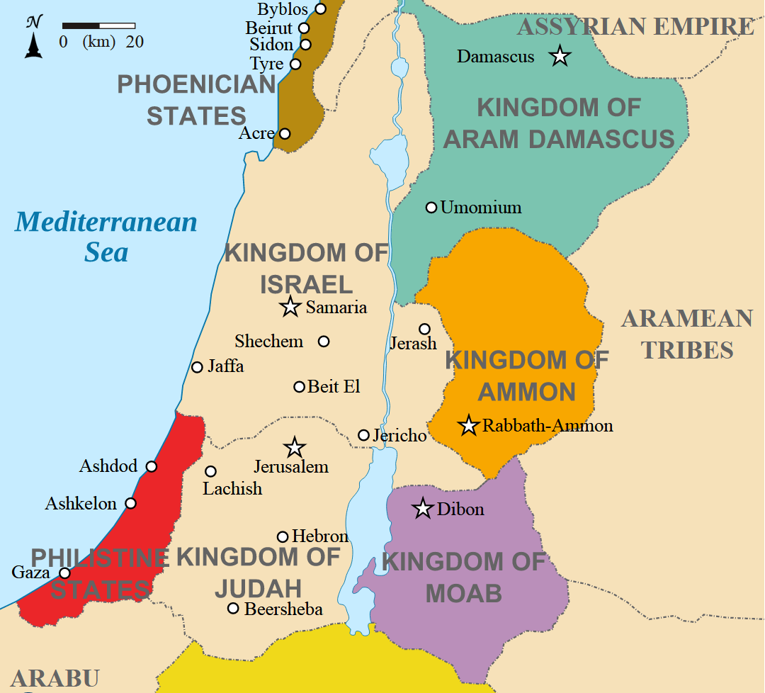

Fig. 11. Map of Palestine ca. 830 BCE. From https://upload.wikimedia.org/wikipedia/commons/d/d2/Kingdoms_around_Israel_830_map.svg

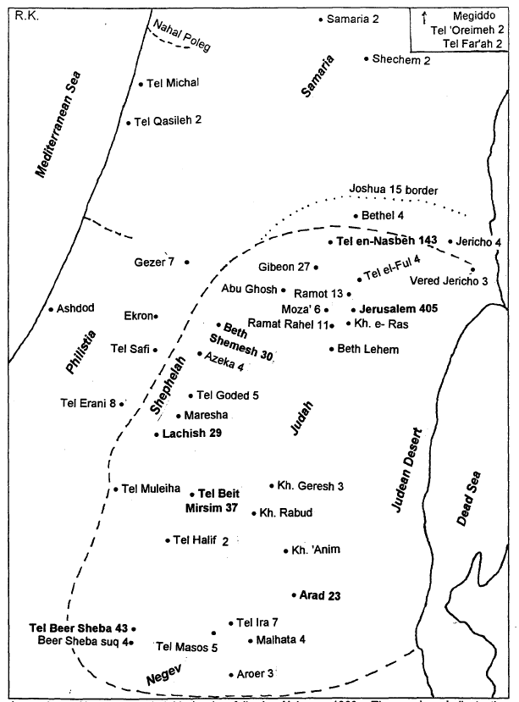**Cultural Affiliation:** Canaan/Philistia, Judah

**Medium:** Terracotta.

**Dimensions:** as indicated

**Weight: as indicated**

**Condition: original**

**Provenance:** various

**Discussion:** Palestine during the Bronze Age and Iron Ages and included a mixture of peoples from Ugarit (modern Ras Shamra) on the Syrian coast, Canaan-Philistia on the Levantine coast and Judah/Israel west of the River Jordan. The Ugarit goddess Athirat (*’atrt*) and her consort of El was the equivalent of the Canaanite-Philistinian goddess Astarte and her consort El and the Israelite-Judahite Astarte-Asherah (*ʾšrt*) and her consort YHWH (Yamashita 1963: 300). These dyads were viewed as essentially equivalent

Fig. 12. Distribution 255 documented only the Judahite Pillar Figurines or JPF’s with a diffusion to the north and west (Kletter, 1996, 1998). Place names without a number are understood to have one example. This map does not include Philistine Pillar Figurines or PPF’s.

In fact, the ceramic figurines (hereafter called Judahite Pillar Figurines or JPF’s and Philistine Pillar Figurines or PPF’s) are distinguished only by their ceramic types of manufacture: in the latter case they were wheel-made with hollow bases and with hand-molded heads and in the former case they were sculpted with solid bases into which mold-made heads were inserted. In either case, the theologies behind their appearances answered the same impulse. They were worshipped not as material objects but as the object in which spirits inhered; some may call them idols, but the practice has not disappeared after three millennia.

Whether in Canaan/Philistia or Israel/Judah, Astarte-Asherah was an affirmation of the equality of the female deity with the male deity, EL/YHWH. By extension, she was an affirmation of the equality of women and men in Palestinian society. She validated women’s rôles in the performance not only of cultic duties but also of political and social duties as well.

Previous to ca 2000 CE it had been assumed that the return of exiles from the 70-year Babylonian Captivity in ca 586 BCE, the so-called Deuteronomists interpolated their prohibition of the worship of Astarte-Asherah and the Canaanite-Philistinian theology into the Pentateuch and other books of the *Hebrew Bible*. It has now been demonstrated that it was not until the prophet Ezra in ca 398 BCE that these prohibitions were actually decreed.

These figurines, therefore, are a testimony of the religion of Judah-Israel before this series of decrees and the abandonment not only of the principle of gender equality but also of the principle of cultural equality. Today the Canaanite/Philistine cultural category has become associated with the Palestinians. They are believed to be the peoples vilified by Ezra and his colleagues in the *Hebrew Bible.* Consequently, the Palestinians have been kept in limbo without a valid government or a cultural heritage recognized by the State of Israel. These figurines, then, are a testimony of their ancient heritage and its right to be recognized.

In the Canaanite/Philistine pantheon and in Judah, Astarte-Asherah was a pre-eminent goddess: women and men were considered equal religiously, socially and politically. In Judah, this is most clearly indicated when the *gibira* or Queen Mother’s religious responsibility was cited in 1 Kgs 15:13 (2 Chr 15:16), in which Ma'acah, the Queen Mother of Asa was removed as *gebira* because “she made a *la ’asherah* *mipleset*” – “she made for Astarte-Asherah [the goddess] an image to shudder at.” The noun *mipleset*, from the verb *pls*, “to shudder” occurs only in 1 Kgs 15:13 and 2 Chr 15:16. The use of this unique noun in the *Hebrew Bible* links this proclamation specifically to the Chronicler who was a contemporary and perhaps an associate of Ezra. 398 BCE is the date of Ezra’s mission to Jerusalem in the 7th regnal year of Artaxerxes II, and it marks the proto-canonization of the Torah under Ezra and his circle with certain modifications made after Ezra’s time (Römer 2005: 179; Fantalkin and Tal 2012: 159-161).

Both Ezra and the Chronicler were complicitous in their effort to silence women’s worship of Astarte-Asherah by casting aspersions on Asherah’s cultic statues, especially the one that was made by the *gibira*. Women’s involvement in religion as well as in politics was at stake, since the Queen Mother was politically responsible for interviewing, selecting and appointing the ruler next in line as well as being responsible for other cultic activities. This process was misogynistic since women lost not only their equal religious stature with men but also their social and political rights as well. According to Gen. 2:22-23 woman was created to help and assist man, and in Gen.3 she effectually brought sin into the world, that the god of Israel was incontrovertibly male, that feminine names with a theophorous element y(h)w are found in only about ten percent of Biblical names, that only the first born male child had to be dedicated to YHWH and that male circumcision was the only physical act that had religious meaning on the believer (Gen. 17: 10-14). A wave of misogynist, anti-Canaanite/Philistine fervor by Ezra was interpolated into the books of Deuteronomy, Joshua, Judges, Samuel, Kings and Jeremiah (Knight 1995).

In this process of reconceptualizing the foundations of the *Hebrew Bible*, the cult of Astarte-Asherah of the Canaanites/Philistines and the Judahites was condemned along with Astarte-Asherah’s cultic objects such as terracotta pillar figurines, incense stands, and model shrines, wooden sacred tree statues and Asherah poles:

ebrew Bib;e be;lH

**Exodus 34:13** 13You shall tear down their altars, break their pillars, and cut down their sacred poles (Asherim) 14(for you shall worship no other god, because the Lord, whose name is Jealous, is a jealous God). 15You shall not make a covenant with the inhabitants of the land, for when they prostitute themselves to their gods and sacrifice to their gods, someone among them will invite you, and you will eat of the sacrifice. (New Revised Standard Version Bible: Anglicised Catholic Edition)

**Deuteronomy 7:5**5 **This** is what **you** are to do to **them**: **Break** **down** **their** **altars**, smash their sacred stones, cut down their Asherah poles and burn their idols in the fire. New International Version

**Deuteronomy 12:3** Break down their altars, smash their sacred stones and burn their Asherah poles in the fire; cut down the idols of their gods and wipe out their names from those places. New International Version

**Deuteronomy 16:** [**21**](http://biblehub.com/deuteronomy/16-21.htm) Do not set up any wooden Asherah pole beside the altar you build to the Lord your God, [**22**](http://biblehub.com/deuteronomy/16-22.htm) and do not erect a sacred stone, for these the Lord your God hates. New International Version

**Judges 3:7** The Israelites did what was evil in the sight of YHWH, forgetting YHWH their God, and worshiping **the Baals and the Asherahs**. New International Version



Fig.13. Painting on Pithos A, Kuntillet 'Ajrud, after Beck 2002: 98, fig. 4.

The date-palm painting from Kuntillet ’Ajrud depicts an  as a stylized fruiting date-palm with its criss-crossed bark and an expanding base showing its above-ground root system. This same expanding base structure was incorporated into the modelling of the bases of the Astarte-Asherah figurines. Moreover, the sacred date-palm was clearly referred to by Biblical terms such as "planting" it (Deut 16:21), or by destroying it when it was “cut down”, “hewn down”, “uprooted”, and “burned”. In Fig. 13 caprids eat from the sacred tree above a *male* lion, YHWH’s sacred animal. (Astarte-Asherah’s sacred animal was the female lioness.) Therefore, we have a composite image with Astarte-Asherah and a source of life and YHWH as a source of protection.

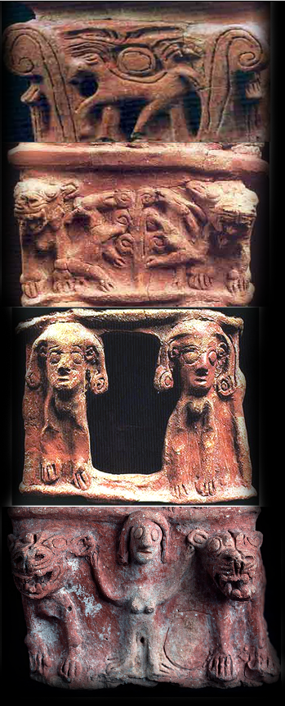

Fig. 14. Terracotta incense burner from Tanaach showing various images and symbols of Astarte-Asherah. After http://cdn.biblicalarchaeology.org/wp-content/uploads/taanach-cult-stand.jpg?x10423

The Tanaach incense burner provides another insight into Astarte-Asherah’s iconography. Tanaach was identified in the *Hebrew Bible* as a Canaanite city (Josh. 12. 21; Josh. 17. 11; Judg. 1. 27), implying a heterodox settlement in its worship of Astarte-Asherah.

The Tanaach incense burner has four panels. The series of four panels suggest that this is the ladder to the sky for the deceased. Therefore, we shall begin with the first or lowermost panel and work our way upwards.

In the first panel, Astarte-Asherah is depicted as a nude female grasping the ears of two lionesses, her sacred animal. In the second panel she is depicted as Hathor the Egyptian cow goddess, giver of sustenance. In the third panel Astarte-Asherah is depicted in a scene as a sacred date-palm providing sustenance to two caprids between two lionesses, her sacred animal. Finally, in the fourth panel Astarte-Asherah holds up the sky symbolized by the winged disk suspended in the *echinus* between the Proto-Aeolic capitals. These capitals had originated in Palestine as an architectural feature of the ashlar masonry construction system, which was characteristic of the royal centers of Israel in the Iron Age, so it was an old image (of which 34 examples are extant) now being put to use as a cultic object of Astarte-Asherah (Shiloh 1976). The winged disk symbol had diffused from Egypt (where it was a symbol of Ra) then to Byblos in Syria and then to Palestine (where it was first used on scarabs, which preceded its first use on Middle Egyptian scarabs). Finally, it came to be incorporated into this incense burner in Tanaach. This documents how the symbol system of the Levant was such an intricate fusion of many cultures (Ornan 2005).

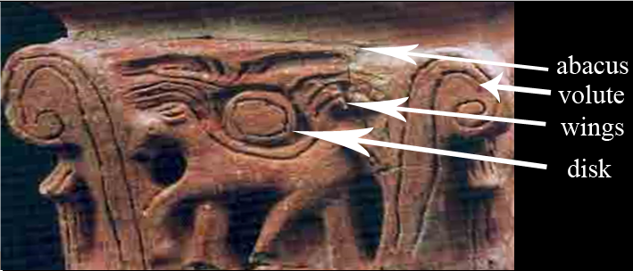

Fig. 15. Top panel, terracotta incense burner from Tanaach showing details of winged disk in the *echinus* between the date-palm volutes.

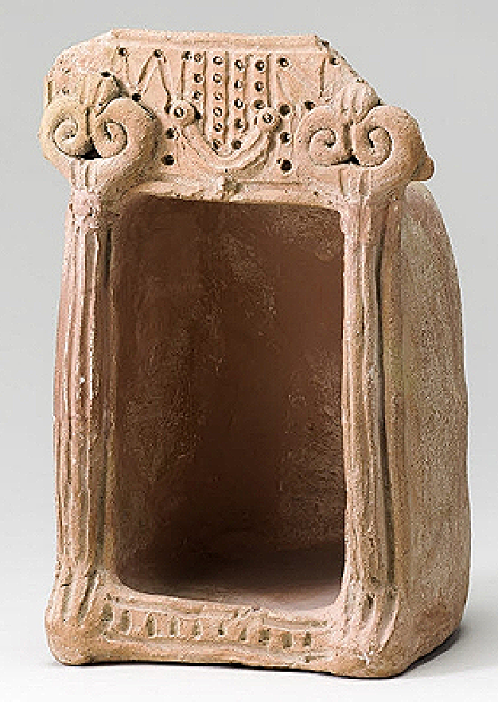 

Fig. 16 a-b. Astarte-Asherah model shrine from Tell el-Far`ah (house 149a), Transjordan, Iron Age Period I (ca 10th century BCE). H. 20.8 cm; W. 14 cm, Louvre Museum, Acc. No. AO 21689. (From Keel and Uelinger 1998, p. 162, fig. 188a).

This Astarte-Asherah model shrine was found inside a house on the site of northern Tell al-Farar, which indicates that it was probably used in private religious rituals. It is in the shape of a *cella* or holy-of-holies and has its entrance flanked by two  or date-palm tree-columns (sacred to Astarte-Asherah) topped with Proto-Aeolic capitals, in which the date-palm fronds in these capitals are turned upwards. The capitals also have two broken figures on top of them that resemble feline paws, which may have been attached to a feline body above the shrine. The columns of this shrine have fluting, which in its bottom terminus bends outward and appears like the toes of a foot (see Fig. 16 b). Could these columns be an image of the Twins, Shahar and Shalim (the "Gracious Gods" of Dawn and Dusk), who are associated with Astarte in an Ugaritic text (KTU 1.23)? It was reported that oaths were sworn before Israel's , which may mean before columns that act as idols (objects in which the spirits of deities inhere, i.e., panentheism) for these “Gracious Gods” or at any rate before Astarte-Asherah’s sacred date-palm  (Dijkstra 1998). Amos (8.14) who was active during the reign of Jeroboam II, (788–747 BCE) wrote the first prophetic book while living in Tekoa, a town in Judah south of Jerusalem (Amos 1:1), but he preached in Israel. He scornfully notes (Amos 8:14) that oaths were sworn “by the sin of ” shrt shmrn (which is mentioned also in 2 Kings 13.6) and may refer to worshippers as they entered the cella of the goddess.

The small round holes in the upper part of the shrine's entablature represent dove-cots or nesting places for domesticated doves (Cant. 2:14; [Jeremiah 48:28](http://biblehub.com/jeremiah/48-28.htm); [Isaiah 60:8](http://biblehub.com/isaiah/60-8.htm)). These are probably for the Eurasian collared dove (*Streptopelia decaocto*) that are sometimes kept in aviculture in Palestine and form dedicated relationships with each other. Doves were thought to emulate loyalty and the flight of the soul to the hereafter and were the only birds that could be offered in sacrifice, as they were considered “clean” according to the Mosaic law ([Genesis 15:9](http://biblehub.com/genesis/15-9.htm); [Leviticus 5:7](http://biblehub.com/leviticus/5-7.htm); [12:6](http://biblehub.com/leviticus/12-6.htm)). They also played a central role in the worship of Astarte-Asherah.

A garland-like stand between the capitals has a miniscule base attached to the transom beam of the portico. Connected to it are four upright columns and two partial ones at either end containing eighteen dove-cot holes in all. It appears that this may be a proto-menorah, suggesting a relationship with the worship of Astarte-Asherah. Six upright columns on a menorah would symbolize six branches of knowledge with the seventh branch, which is the divine guiding light, having yet to be installed but was probably silently understood.

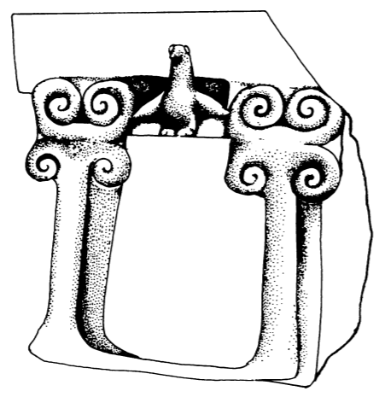

Fig 17. Astarte-Asherah model shrine from Transjordan. (Rockefeller Museum, Jerusalem; Iliffe 1945).

Fig. 17 is an Astarte-Asherah model shrine in the shape of a *cella* or holy-of-holies from Transjordan and is flanked by two date-palm columns with Proto-Aeolic date-palm capitals with double volutes one pointing up and one pointing down. These columns are the  poles that were cited for destruction by the redactor of the Pentateuch. Between the columns and above the portico is Astarte-Asherah’s emblematic bird, the dove, with wings outstretched.

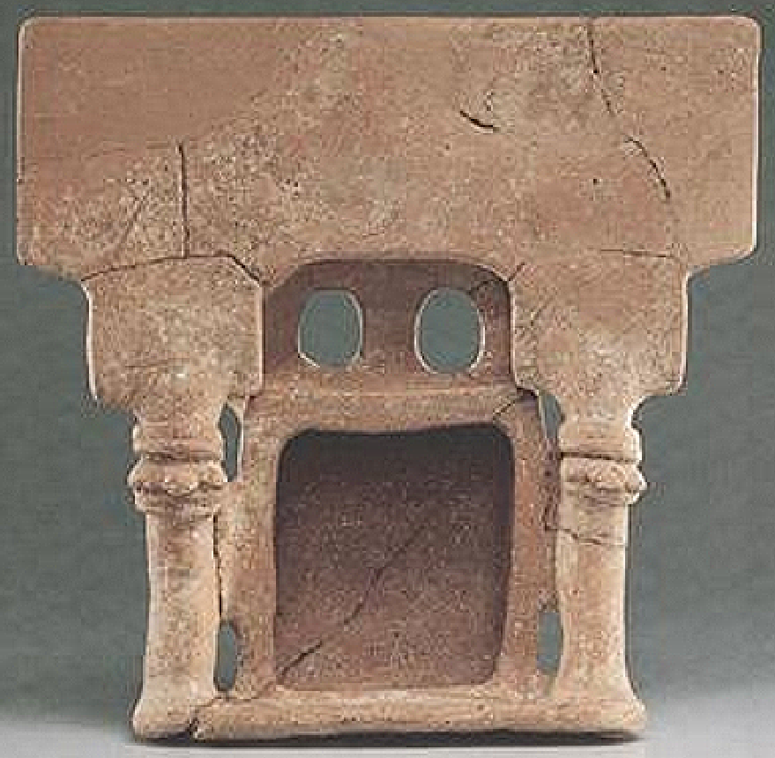

Fig. 18. Astarte-Asherah shrine from Mt Nebo, Iron Age II (9th-8th cent. BCE), Transjordan, in the shape of a cella. Israel Museum, Jerusalem. H 29 cm (11 1/2 in) W 31 cm (12 1/4 in) (From Lewitt 1995: 64).

This rectangular, terracotta, model shrine consists of a *cella* or holy-of-holies with its entrance flanked by columns topped by date-palm capitals with fronds extended. The date-palm was the sacred tree of Astarte-Asherah and from which  poles were made. This model was probably presented to Astarte-Asherah in Her temple or kept at home for private cultic use, since it was not found in association with any tombs.

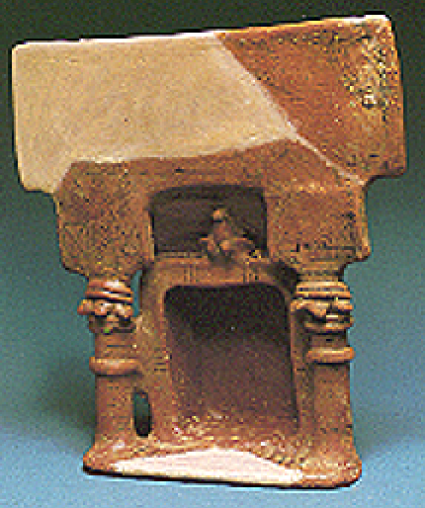

Fig. 19. Astarte-Asherah shrine in the shape of a cella Iron I Period (ca 10th century BCE) from Transjordan from the Reuben and Edith Hecht Museum, Haifa. From Hachlili and Meshorer 1990: 42.

This shrine of Astarte-Asherah represents a single room, the *cella* or holy-of-holies; the portico is flanked by two columns topped with date-palm capitals that represent the sacred tree image of Astarte-Asherah. The dove above the portico attests to its connection to Astarte-Asherah.

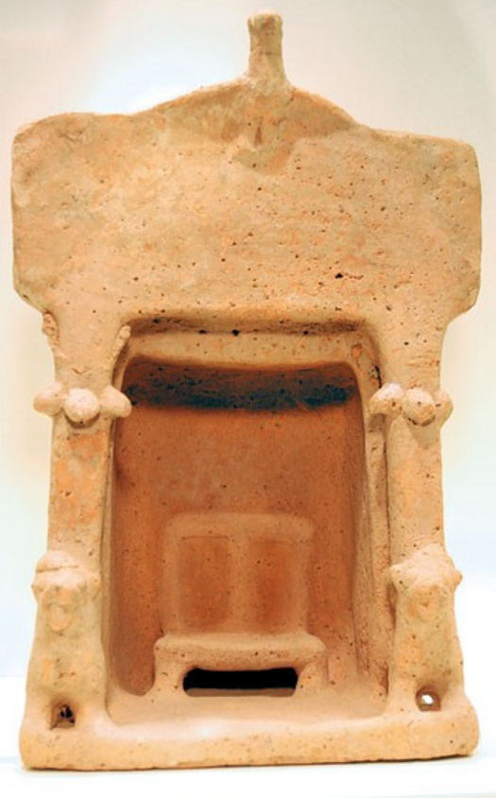

Fig. 20. Astarte-Asherah shrine in the shape of a cella Iron I Period (ca 10th century BCE. From <http://www.baslibrary.org/sites/default/files/bsba340205500l.jpg>

This shrine of Astarte-Asherah has a single room, the *cella* or holy of holies; the portico is flanked by two date-palm columns with date-palm frond capitals that represent the sacred tree of Astarte-Asherah. In front of the two columns are two lionesses, the animal sacred to Astarte-Asherah. The dove with outstretched wings above the portico attests to its connection to Astarte-Asherah as her emblem.

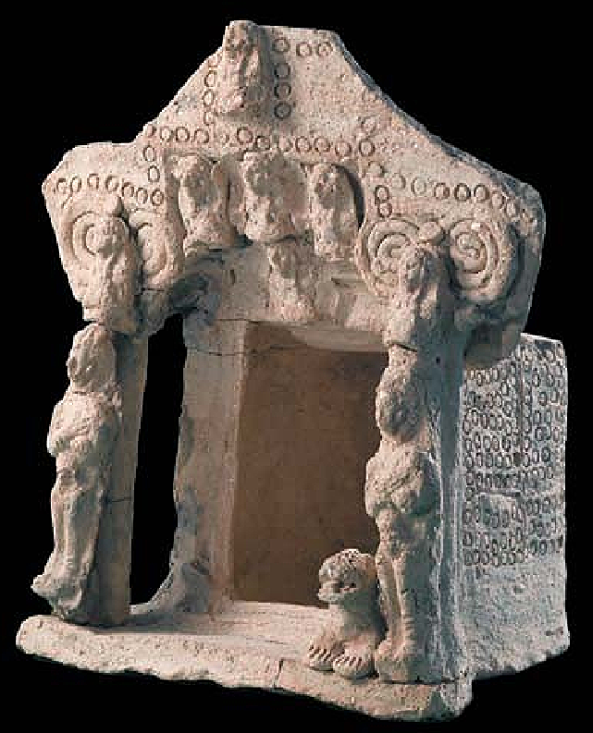

Fig. 21. Shrine of Astarte-Asherah (Athirat), and Anat. From http://members.bib- arch.org/sites/default/files/styles/xlarge/public/bsba310602100l.jpg?itok=YCv6kAX, Ardon Barhama.

This complicated, 6-inch-wide shrine with a single room or *cella*, features two columns with Proto-Aeolic capitals and date-palm volutes. In front of the columns are two male figures who may be the twins, Shahar and Shalim, the Ugaritic gods of dawn and dusk associated with the planet Venus and with Astarte-Asherah in an Ugaritic text (KTU 1.23) before whom oaths were sworn before entering an Astarte-Asherah shrine (Dijkstra 1998). Beside these figures are two crouching lionesses (one is missing, Astarte-Asherah’s sacred animal) and above the two figures are two crouching male lions. Above the entrance are the three goddesses of the Canaanite/Philistine pantheon Astarte, Asherah (Athirat), and Anat with their combined oneness (three-in-one hypostasis) indicated by the female figure below them. Above them is their consort, YHWH/El. The shrine has several impressed circles perhaps indicating dove-cots, signifying the bird sacred to Astarte-Asherah. The shrine may have come from southern Palestine and is dated by its iconography to the tenth-ninth century BCE, which was confirmed by thermoluminescence. It may have been offered to a god in a temple, placed in a tomb or used in a ritual at home.

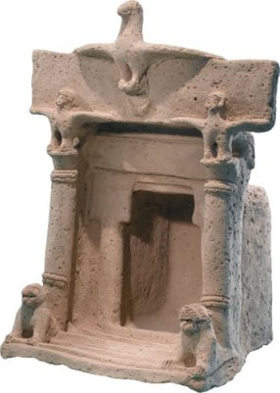

Fig. 22. Trans-Jordanian model shrine of Astarte-Asherah (Athirat), Astarte, and Anat from a private collection https://ochesnut.files.wordpress.com/2012/05/birddove2bar112509naos1.jpg?w=429&h=602

This shrine of Astarte-Asherah has a single room, the *cella* or holy of holies; the portico is flanked by two columns crowned by two unusual capitals with two birds perched on them with outstretched wings. The entablature is surmounted by a dove, also with outstretched wings. The three birds may be the three goddesses associated with Asherah, Astarte, and Anat.

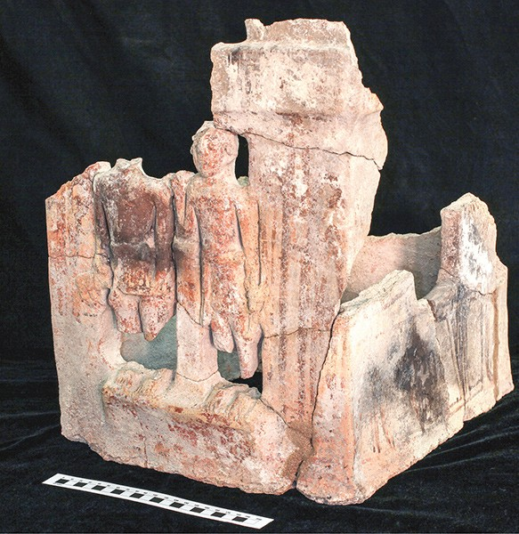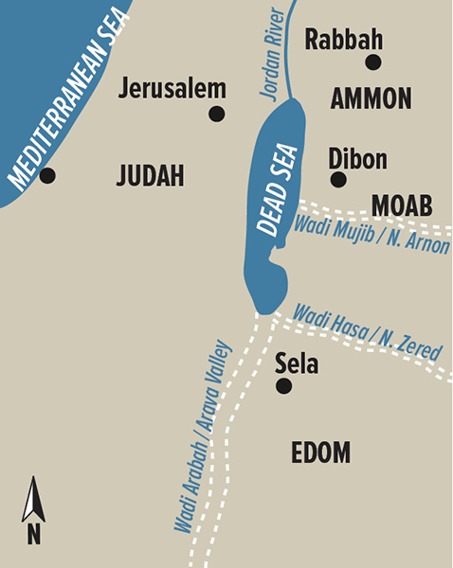

Fig. 23. The ‘Aṭaruz Temple, a ninth-century BCE Moabite temple from Khirbat ‘Aṭaruz. Photo by Joel S. Burnett. From <http://members.bib-arch.org/sites/default/files/bsba420603600l.jpg>

Khirbat ‘Aṭaruz is a site potentially identified with Biblical Ataroth and located in Jordan about 7 miles east of the Dead Sea. Many cultic artifacts were found in this Iron Age temple, including a ceramic bull statue and a terracotta shrine model (shown here)—both of which date to the ninth century BCE. The bull statue was uncovered in the temple’s central courtyard, and the terracotta shrine model came from the temple’s main sanctuary. This fenestrated multi-story shrine model was originally painted and has two male figures standing in two of its openings.

The Moabites were identified in the Hebrew Bible’s as “the children of Ammon” (bĕnê ‘Ammôn, e.g., 1 Kings 11:7, 33) matches the threefold reference in the Ammonite Tell Siran Inscription, “the king of the children of Ammon” (mlk bn ‘mn; c. 600 B.C.E.; cf. mlk bny ‘mwn, Jeremiah 27:3). This kin-based formulation of political identity reflects a tribal social makeup and kingdom organization analogous to that of ancient Israel, “the children of Israel” (bĕnê yiśrā’ēl), Judah and Canaan/Philistia. In fact it is impossible to separate these tribal-ethnic entities archaeologically. However the Hebrew Bible redactors in 1 Kings were explicit in their condemnation of the Edomites:

1 Kings 11:7 Furthermore, on the hill east of Jerusalem Solomon built a high place for the detestable Moabite god Chemosh and for the detestable Ammonite god Milcom. 1 Kings 11:33 I am taking the kingdom from him because they have abandoned me and worshiped the Sidonian goddess Astarte, the Moabite god Chemosh, and the Ammonite god Milcom. They have not followed my instructions by doing what I approve and obeying my rules and regulations, like Solomon’s father David did.

Chemosh was the pre-eminent Moabite god associated with the Semitic goddess Ashtar-Chemosh, who is mentioned on the Moabite Stone (or Mesha Stele) as Chemosh’s equal female counterpart and who is indistinguishable from Astarte-Asherah (Moabite Stele, line 17; Baethgen 1888, p. 14). Chemosh’s support was sometimes invoked by human sacrifice (II Kings iii. 27), and when help would come, a sanctuary would be dedicated to him (Moabite Stone, line 3). An ancient poem, twice quoted in the *Hebrew Bible* (Num. xxi. 27-30; Jer. xlviii. 45, 46), regarded Moabites as Chemosh’s progeny suggesting that originally he was a deified king.

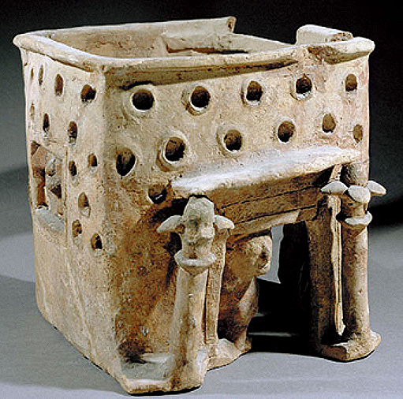

Fig. 24. Cypro-Archaic (6th century BCE) model of a corniced shrine of Astarte-Asherah from the Idalion necropolis, Cyprus, terracotta, Louvre Museum, Acc. No. N 3294, acquired by Georges Colonna-Ceccaldi, ca 1869. Photo by Pierre and Maurice Chuzeville

From: <https://s-media-cache-ak0.pinimg.com/originals/f8/b3/3d/f8b33d77bcca17f9555a68f300002b6a.jpg>

This corniced, rectangular, terracotta Cypriot shrine of Astarte-Asherah was found in a grave in the Idalion necropolis, Cyprus (See Caubet 1979; Caubet, Hermary and Karageorghis 1992; Caubet and Yon 2001: 154, fig. 7). It depicts the goddess, Astarte-Asherah, in the windows on the left and right sides, which was associated with Aphrodite-Parakyptousa or “Aphrodite leaning from the window” by Greek Cypriots (Karageorghis1977: 203). Astarte-Asherah’s symbols, two columns with date-palm capitals as the sacred tree, are similar to the columns of the great shrine of Astarte in Kition, Cyprus and similar to those from Canaan/Philistia and Judah. The third figure, shown in the threshold, is a winged siren (half-woman, half-bird) that was believed to accompany the deceased on the final journey. This model shrine had been left in a grave so that Astarte-Asherah – as the woman at the window--the goddess of fertility and rebirth could intercede for the deceased, and the siren, who guides the souls of the deceased to world hereafter could act on his behalf.

**Images of YHWH: Masseboth and Philistine Currency.**

Images of YHWH were banned as well. When YHWH was introduced into the Canaanite/Philstine pantheon as the deity worshipped by the Shasu Bedouin nomads of s Transjordan who had received the god from Egypt (Dever 2003: 128), YHWH was combined with the Judahite Astarte-Asherah. The first images of YHWH and Astarte-Asherah were two standing stones. At least 142 *masseboth* sites are documented in s Negev and e Sinai. Most face e with a circular cell, offering benches, and altars.

At Hazor is a Yahweh *massebot* in the shape of the male generative organ beside which an “” pole may have been “planted”.

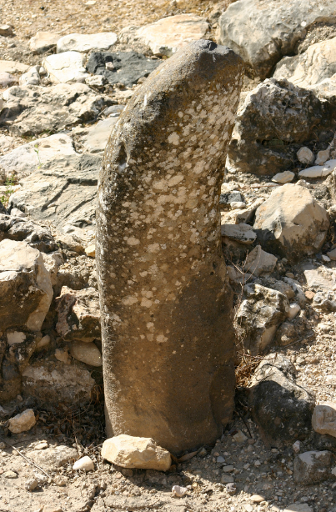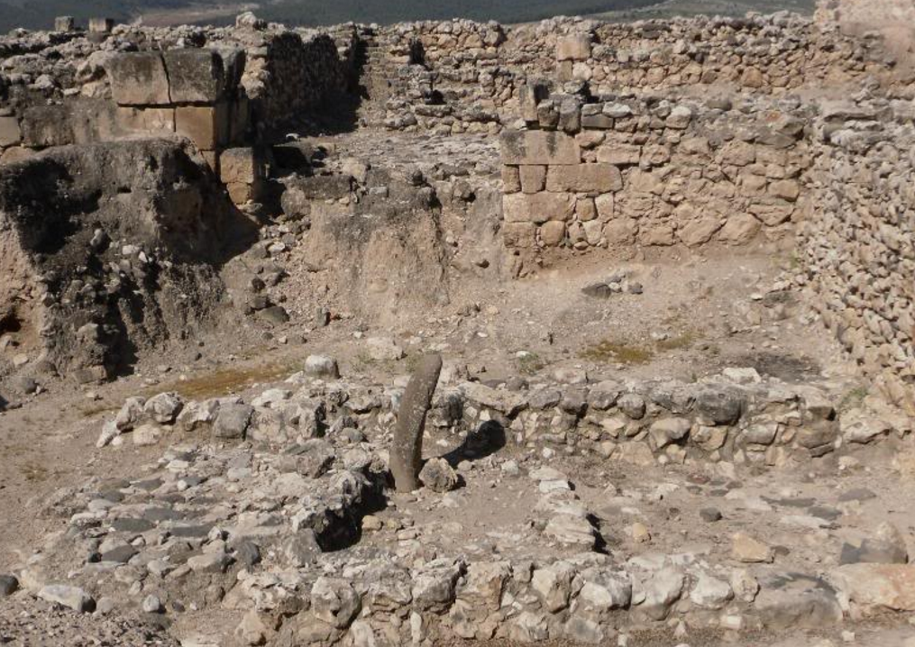

Fig. 25 a-b. A Yahweh *massebot* at the Yahweh shrine at Hazor. From http://i841.photobucket.com/albums/zz337/tara7445/Israel%20Trip/604.jpg

Note the similarity of Fig. 25 a-b to the male generative organ. This is a sign of the covenant of YHWH and the people:

Gen. 17:10 This is my covenant with you and your descendants after you, the covenant you are to keep: Every male among you shall be circumcised. 11 You are to undergo circumcision, and it will be the sign of the covenant between me and you. 12 For the generations to come every male among you who is eight days old must be circumcised, including those born in your household or bought with money from a foreigner—those who are not your offspring. NIV

Previously, this *massebot* had been termed an  pole but an  pole would have been a straight wooden date-palm column topped by a Proto-Aeolic Capital with date-palm volutes. Gen. 28: 10-22 relates how Jacob at Bethel had a dream in which YHWH was present in a particular stone, which he proclaimed upon wakening, “This stone shall be YHWH’s house.” This concept of panentheism or the spirit of a deity inhering in a material object is captured in the *massebot* above.

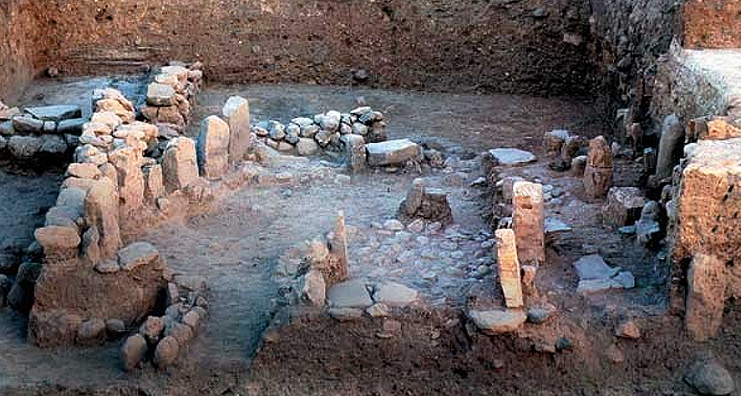

Fig. 26. Another Hazor *massebot* sanctuary, Middle Bronze Age II (ca 1800–1550 BCE), shortly after the foundation of Hazor.

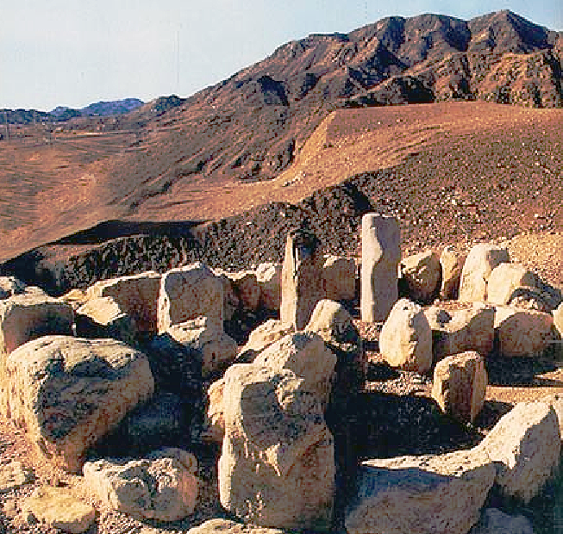

Fig. 27. Masseboth, ca 7,000 BCE near Eilat, in s Negev desert. Photo Hershel Shanks. http://members.bib-arch.org/sites/default/files/styles/xlarge/public/bsba270303000l.jpg?itok=R2unMRTD

Masseboth within a circle usually represent ancestral spirits, but in the figure above the two broad stones at the extreme left on the perimeter or east may represent YHWH and Astarte-Asherah. The pre-Ezra tradition of erecting masseboth for significant events is well attested. Moses set up 12 masseboth at Mt. Sinai at the ratification of the covenant between God and Israel ([Exodus 24:4](javascript:%7b%7d)). Joshua erected a “great stone” at Shechem ([Joshua 24:26–27](javascript:%7b%7d)). Jacob set up a massebah when he awoke from the dream in which he saw a ladder (or stairs) to heaven ([Genesis 28:18](javascript:%7b%7d)). However, with the gradual shift from polytheism to monotheism with Amos as the redactor of [Deuteronomy 16:22](javascript:%7b%7d), masseboth of YHWH and Astarte-Asherah were condemned: “You shall not ... erect a massebah, which the Lord your God detests”. Masseboth have been found at numerous sites in Israel, such as Tel Dan (Biran 24), Arad, Megiddo, and Tel Kitan.

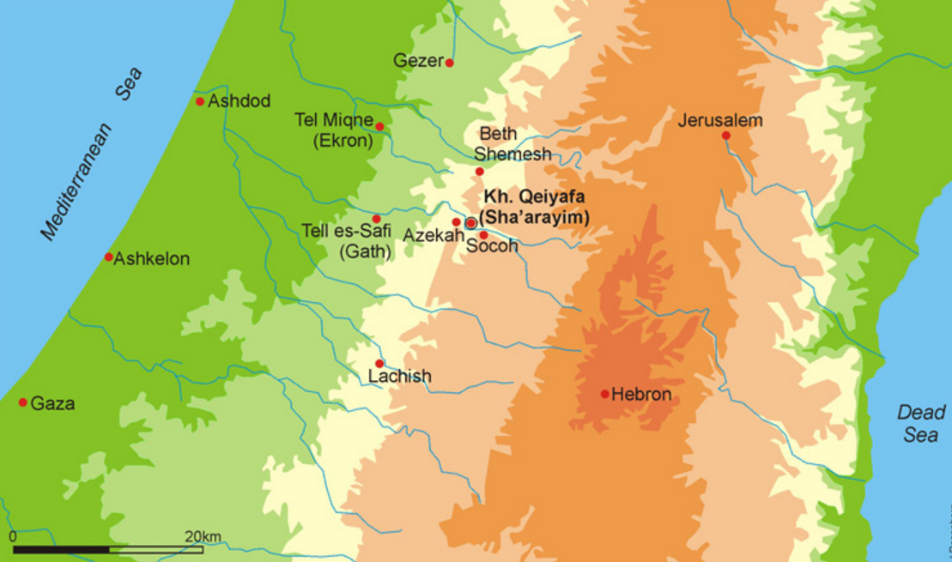

Fig. 28. Map of area between Gaza to Asdod and the Dead Sea. This is the area in which the Philistine mint coins from have been found.

YHWH was also depicted on Philistine mint coins which were produced by Edomite Jews (Gitler and Tal 2006).

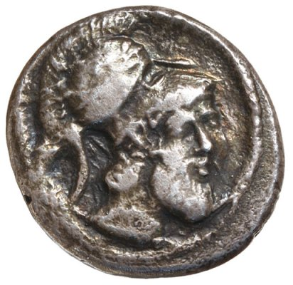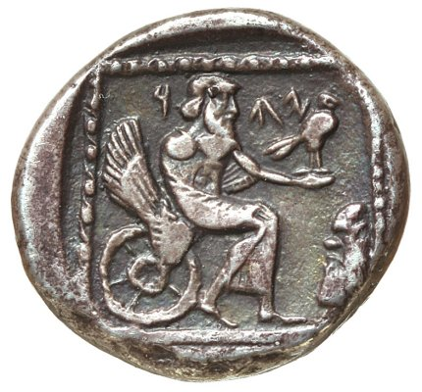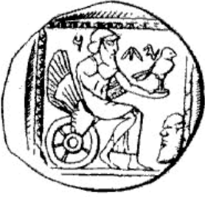

Figs. 29. Quarter shekel from the Philistine mint (obverse) (Australian specimen from Pitchfork 2012) Figs. 26-27 reverse Australian specimen, and drawing of the reverse of the British Museum specimen in Cook (1914: Fig. 171b).

The obverse of this quarter shekel shows a floral, spiral-border enclosing a circular-incuse with a bearded divinity head facing towards the right wearing a Corinthian-crested helmet surmounted by a bay-leaf wreath. Perhaps this is YHWH victorious in battle and equated with the Corinthian Zeus.

The reverse shows a floral, spiral-border enclosing a square-incuse with a bearded divinity enthroned on an archaic six-spoked wheel which has an ornamental wing as its high back with 10 fletches. YHWH is wearing a himation gown (toga) with a border of circular objects (jewels?) draped over his left arm while it completely covers his right arm and his legs. He is holding an owl (?) (*Athene noctua*, Athena’s bird) on his out-stretched left hand that traditionally represents the virgin goddess of wisdom. In the lower right-hand corner of the spiral border is an enigmatic, bearded head. El is depicted as qds “holy” KTU 1.16 i:11.22) in the Ugarit texts and appears as an aged deity with a grey-white beard. This bearded head may be El looking at YHWH on his wheeled-throne, as both give a pronouncement of wisdom:

When the cherubim moved, the wheels beside them moved;

and when the cherubim spread their wings to rise from the ground,

the wheels did not leave their side. Ezekiel 10:16 (NIV).

Above the seated YHWH are Phoenician letters that can be translated as either YHW (YHWH) (C. Clermont-Ganneau 1880; Hill 1914) or YHD (Yehud=Judah) (Barag 1991). In either case it depicts the divinity YHWH of Judah. As Cook (1914) asserted “There can, in fact, be little doubt that we have here a gentile representation of [YHWH]. … It is more likely that Yaw of Gaza really represents the Hebrew, Phoenician and Aramaic Sun-god, El, Elohim, whom the monotheistic tendencies of the Hebrews had long since identified with Yaw [=YHWH]” (cf. Lipinski 1992: 387).

Another image of YHWH on a coin from the Philistine mint in Gaza was excavated at Khribet Qeiyafa (Fahi 2014). The reverse of this coin also shows the iconography of a bearded YHWH with his right arm extended with a raptor (owl?) perched on his hand. His left hand holds a long staff. Behind him in relief are the Greek letters AAEEANA perhaps a mantra for Athena. The obverse has the head of a helmeted warrior.



Fig. 30. Coin from the Philistine mint found in Khribet Qeiyafa (Fahi 2014) Photo: Clara Amit.

In conclusion, images of YHWH and Astarte-Asherah were present among Judahites from the Late Iron age I through the period after Amos had redacted the Pentateuch in 398 BCE. The prohibition of graven images which was interpolated into the Pentateuch at this time was a response to an emergent theo-ethno-centrism that sought to restrict Canaanite/Philistine neighbors from Israelite temples of worship. Asherah/Astarte figurines,  cultic installations and shrines became objects of destruction along with YHWH’s *masseboth* and Philistine coins with His images. In addition, the elimination of Astarte-Asherah from the Judahite pantheon was paralleled by a growing emphasis on the worship YHWH alone with the concomitant social result -- the suppression of women in positions of authority in religion and society and the elevation of men.

**References**

Ahituv, Shmuel. 2007. “Shmuel Ahituv responds to Dever’s response,” *Biblical Archaeological Review*, May/June.

Ahituv, Shmuel. 2006. “Did God Really Have a Wife?” *Biblical Archaeological Review*, September/October.

Albright, W.F. 1939. “Astarte Plaques and Figurines from Tel Beit-Mirsim,” in *Mélanges Syriens offerts à monsieur René Dussaud*. Paris: Librarie Geuthner, pp. 107-20.

Barag, D. 1991. [*Studies in memory of Paul Balog*](http://www.worldcat.org/title/studies-in-memory-of-paul-balog/oclc/475335843&referer=brief_results). Jerusalem, London: Israel Numismatic Society: Spink & Son.

Baethgen, Friedrich. 1888. *Beiträge zur semitischen Religionsgeschichte : der Gott Israel's und die Götter der Heiden.* Berlin: H. Reuther's Verlagsbuchhandlung.

Biran, Avraham. 1998. “Sacred Spaces: Of Standing Stones, High Places and Cult Objects at Tel Dan,” *Biblical Archaeological Review*, September/October, 24:05.

Block, Daniel. 1999. Judges, Ruth: An Exegetical and Theological Exposition of Holy Scripture (The New American Commentary) Nashville, TN: Broadman & Holman.

Byrne, R. 2004. “Lie Back and Think of Judah,” *NEA* 67(3):137-51;

Caubet Annie, "Les maquettes architecturales d'Idalion", in *Studies presented in memory of Porphyrios Dikaios*. Nicosia, Cyprus, 1979, pp. 94-118.

Caubet Annie and Marguerite Yon. 2001. "La tradition des maquettes architecturales de Chypre", in *Maquettes architecturales de l'Antiquité : regards croisés (Proche-Orient, Égypte, Bassin égéen et Grèce, du néolithique à l'époque hellénistique)*, Actes du colloque de Strasbourg, 3-5 décembre 1998, sous la dir. de Béatrice Muller avec Denyse Vaillancourt, Strasbourg, Publications de l'université de Strasbourg II, Paris, E. de Boccard, 2001, pp. 143-160.

Caubet Annie, Hermary Antoine, Karageorghis Vasos. 1992. *Art antique de Chypre au Musée du Louvre* : du chalcolithique à l'époque romaine. Paris: Éditions de la Réunion des musées nationaux.

[Cook, Arthur Bernard](http://library.tufts.edu/search~S1?/aCook%2C+Arthur+Bernard%2C+1868-1952./acook+arthur+bernard+1868+1952/-3,-1,0,B/browse). [1914-1940] 1964-65. **Zeus; a study in ancient religion.** v.1. Zeus, god of the bright sky.--v.2. Zeus, god of the dark sky (thunder and lightning) 2 pts. New York, Biblo and Tannen.

Dever. William G. 2006. “William G. Dever responds to Shmuel Ahituv,” *Biblical Archaeological Review*, November/December.

Dever, William G. 2005. *Did God Have a Wife?* Grand Rapids: Eerdmans, pp. 176-208.

Dever, William G. 2003. [*Who Were the Early Israelites and Where Did They Come From*](https://books.google.com/?id=A_ByXkpofAgC&printsec=frontcover&dq=who+were+the+early+israelites#v=onepage&q=who%20were%20the%20early%20israelites&f=false)*?* Grand Rapids: Eerdmans.

Dieterich, M., O. Lorentz and J. Sanmartin. 2013. Die keil-alphabetische Texts aus Ugarit; second enlarged edition: The Cuneiform Alphabetic Texts from Ugarit, Ras Ibn Hani and Other Places. Abhandlungen zur Literatur Alt-Syrien-Palastinas und Mesopotamiens. 2nd enl. ed. Münster: Ugarit-Verlag.

Dijkstra, M. 1998. “Astral Myth of the Birth of Shahar and Shalim.” In Manfred Dietrich and Ingo Kottsieper (eds.), *"Und Mose shrieb dieses Lied auf": Studien zum Alten Testament und zum Alten Orient*. Münster: Ugarit-Verlag, 265-87 (esp. 270-1).

Dunn, James G. and John William Rogerston. 2003. *Eerdmans Commentary on the Bible.* Grand Rapids: Wm. B. Eerdmans Publishing.

Engle, J.R. 1979. “Pillar Figurines of Iron Age Israel and Asherah/Asherim,” Ph.D. dissertation, University of Pittsburgh.

Farhi, Yoav. 2016. Khirbet Qeiyafa. Vol. 5, Excavation report 2007-2013: the numismatic finds: coins and related objects. No place: Institute of Archaeology Southern Adventist University; Jerusalem: Israel Exploration Society; Jerusalem: Institute of Archaeology, The Hebrew University of Jerusalem.

Fantalkin, Alexander and Oren Tal. 2012. “The Canonization of the Pentateuch: When and Why? (Part I),”   
*Zeitschrift für die alttestamentliche Wissenschaft,* 124:1-18.

Gitler, Ḥayyîm and Oren Tal. 2006. [***The coinage of Philistia of the fifth and fourth centuries BC: a study of the earliest coins of Palestine***](http://www.worldcat.org/title/coinage-of-philistia-of-the-fifth-and-fourth-centuries-bc-a-study-of-the-earliest-coins-of-palestine/oclc/230187547&referer=brief_results). Milano: Ed. Ennerre.

Grant E. 1932. *Ain Shems Excavations (Palestine) 1928-1929-1930-1931 Part II*. Haverford, PA: Haverford College.

Hachlili, Rachel and Yaakov Meshorer. 199). *Highlights from the Collection of the Reuben and Edith Hecht Museum*, 2d. ed. Haifa: University of Haifa.

Hadley, J. M. 1995. “Wisdom and the Goddess,” in J. Day, R. P. Gordon and H. G. M. Williamson (eds.) *Wisdom in Ancient Israel: Essays in Honour of J. A. Emerton*. Cambridge: Cambridge University Press, pp. 234-243.

Hadley, J. M. 2000. *The cult of Asherah in ancient Israel and Judah: Evidence for a Hebrew Goddess.* Cambridge: Cambridge University Press.

Hess, R. 2007. *Israelite Religions*. Grand Rapids, MI: Baker Academic, pp. 308-11.

Hestrin, R. 1987. “The Lachish Ewer and the ‘Asherah’,” *Israel Exploration Journal,* 37:212-23

Hill, George Francis. 1914. A catalogue of the Greek coins in the British Museum, Catalogue of the Greek coins of Palestine (Galilee, Samaria, and Judaea). London: Longmans.

Holland, T. A. 1977. “A Study of Palestinian Iron Age Baked Clay Figurines with Special Reference to Jerusalem Cave I,” *Levant* 9:121-5.5

Iliffe, J. H. 1945. “A model shrine of Phoenician style,” *Quarterly of the Dept. of Antiquities in Palestine,* 11: 91-2.

Karageorghis Jacqueline. 1977. La Grande Déesse de Chypre et son culte à travers l'iconographie, de l'époque néolithique au VIe siècle av. J.-C., Lyon, Maison de l'Orient, Paris, E. de Boccard,

Keel, O. and C. Uehlinger. 1998. *Gods, Goddesses, and Images of God in Ancient Israel*, trans. T.H. Trapp. Minneapolis: Fortress Press, esp. pp. 325-43.

Knight, Douglas A. 1995. "Deuteronomy and the Deuteronomists". In James Luther Mays; David L. Petersen; Kent Harold Richards, eds. Old Testament Interpretation. Edinburgh: T&T Clark.

KTU = Dietrich, Manfried; Oswald Loretz; and Joaquín Sanmartín. 2013. Die **k**eilalphabetischen **T**exte aus **U**garit, Ras Ibn Hani und anderen Orten = The Cuneiform alphabetic texts from Ugarit, Ras Ibn Hani and other places. Münster : Ugarit-Verlag.

Johnston, P.S. 2003. “Figuring Out Figurines,” *Tyndale Bulletin*, 54(2): 81-104.

Kletter, R. 1996. *The Judean Pillar-Figurines and the Archaeology of Asherah*. BAR International Series, 636. Oxford: Tempus Reparatum.

Kletter R 1999. *Clay Figurines. In: I. Beit-Arieh. Tel 'Ira, A Stronghold in the Biblical Negev*. Jerusalem, esp. 374-394, Fig. 7.1:4.

Lewitt, Irene, ed. 1995. *The Israel Museum*. New York: Vendome Press.

Lipinski, E., ed. 1992. Dictionnaire de la Civilisation Phénicienne et Punique. Paris: Brepols.

Meyers, C. 2007. “Terracottas without Texts,” in R.B. Coote and N.K. Gottwald (eds.), *To Break Every Yoke: Essays in Honor of Marvin L. Chaney*. Sheffield: Sheffield Phoenix Press, esp. pp. 115-30.

Miller, Robert D. 2005. *Chieftains of the Highland Clans: A History of Israel in the 12th and 11th Centuries B.C.,* Wm. B. Eerdmans Publishing.

Moorey, P.R.S. 2003. *Idols of the People*. Oxford: Oxford University Press, esp. pp. 47-68.

Ornan, T. 2005. A Complex System of Religious Symbols: The Case of the Winged-disc in First-Millennium Near Eastern Imagery. In C.E. Suter and Ch. Uehlinger (eds.), *Crafts and images in contact: Studies on eastern Mediterranean minor art of the 1st millennium BCE* (OBO 210), Fribourg & Göttingen, 207-241.

Pakkala, J. 2004. *Ezra the Scribe: The Development of Ezra 7–10 and Nehemiah 8*. Beihefte Zur Zeitschrift Fur die Alttestamentliche Wissenschaft. Berlin - New York: Walter de Gruyter.

Pitchfork, Colin E. 2012. “Biblical Coinage: Coins that have links to Israel and the Bible,” The Australian Numismatic Society Library, http://the-ans.com/library/Conf2012CP1.html

Pritchard, J.B. 1943. *Palestinian figurines in relation to certain goddesses known through literature.* New Haven, CT: American Oriental Society.

[Redford, Donald B.](https://en.wikipedia.org/wiki/Donald_B._Redford) 1992. *Egypt, Canaan and Israel in Ancient Times*. Princeton: Princeton University Press.

Römer, T. 2005. The So-Called Deuteronomistic History: A Sociological, Historical and Literary Interpretation.

Shiloh, Yigal. 1979. *The proto-Aeolic capital and Israel ashlar masonry*. (Qedem II. Monographs of the Institute of Archaeology). Jerusalem: The Hebrew University of Jerusalem.

Shiloh, Yigal. 1976. “New Proto-Aeolic Capitals Found in Israel,” *Bulletin of the American Schools of Oriental Research*, No. 222 (Apr.), pp. 67-77.

Stern, E. 2001. *Archaeology of the Land of the Bible*. AB Reference Library. New York: Doubleday, esp. pp. 205-11

Stern, Ephraim. 2000. "The Babylonian Gap," *Biblical Archaeology Review*, **26** (6).

Teissier, Beatrice. 1996. *Egyptian iconography on Syro-Palestinian cylinder seals of the Middle Bronze Age.*Fribourg; Göttingen: University Press Fribourg Switzerland; Vandenhoeck & Ruprecht.

Yamashita, T. 1963. “The Goddess Asherah.” Ph.D. dissertation, Yale University.

Zevit, Z. 2001. *The Religions of Ancient Israel*. New York: Continuum, esp. pp. 267-74